Test # 288
Instrument Name UCA Right
Instrument Type UCA
Test Start 26/04/01 10:22
Test Stop
Well ID # Pad2-5652
Customer URAY
Cement Class G
Additives 1.4%TDF-1+0.25%SMS+SodaAsh+Defoamer
Cement Mfr DYKERHOFF
BHCT 65
BHST 85
Density 1900
Fluid Loss
Job Type 146 MM CSG
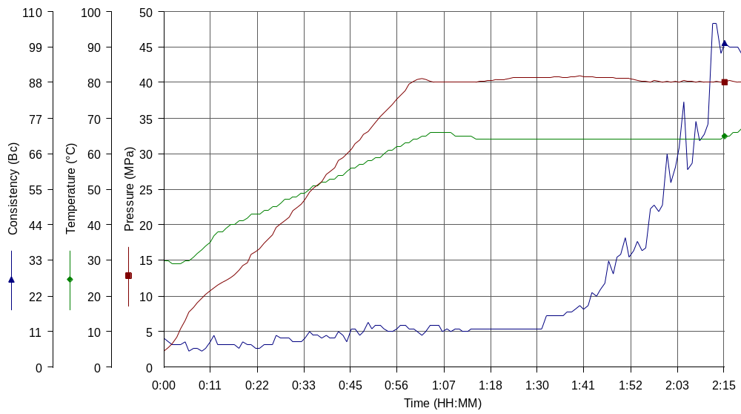
Comments T:65(60min), Astrahan cement, tap water, premix TDF & SMS, H=2900 m

